Chapter 3 p.72

North Korea targeting of national

defense industries

Pie chart showing percentages of the most targeted national defense industries by North Korea in various countries. It shows A. Russia: 14%, B. United States: 10%, C. Israel: 10%, D. Germany: 9%, E. India: 7%, F. Africa: 6%, G. South Korea: 6% H. Türkiye: 4%, I. Brazil: 3%, J. Czechia: 3%, K. Finland: 3%, L. France: 3%, M. Italy: 3%, N. Poland: 3%, O. Norway: 3%, and P. Other: 13%.

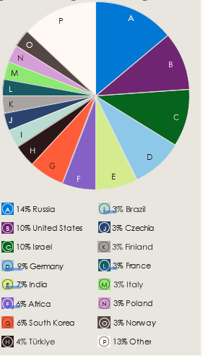

Source: Microsoft Threat Intelligence nation state notifications